Blazor Architecture with ASP.NET Core and .NET

1. Positioning Blazor in the ASP.NET Core | .NET Ecosystem

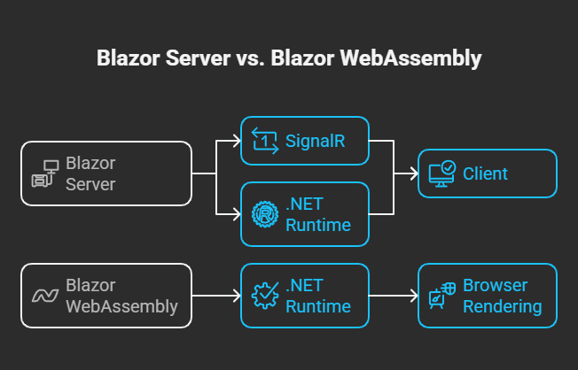

Blazor is a UI framework that runs on top of ASP.NET Core, using the .NET runtime to build interactive web applications with C#.
At a high level:
- ASP.NET Core provides:
  - Web hosting
  - Middleware pipeline
  - Dependency Injection
  - Security (AuthN/AuthZ)
  - Configuration & logging
- Blazor provides:
  - Component-based UI model
  - Client-side routing
  - State-driven rendering
  - SPA behavior

2. High-Level Blazor Architecture
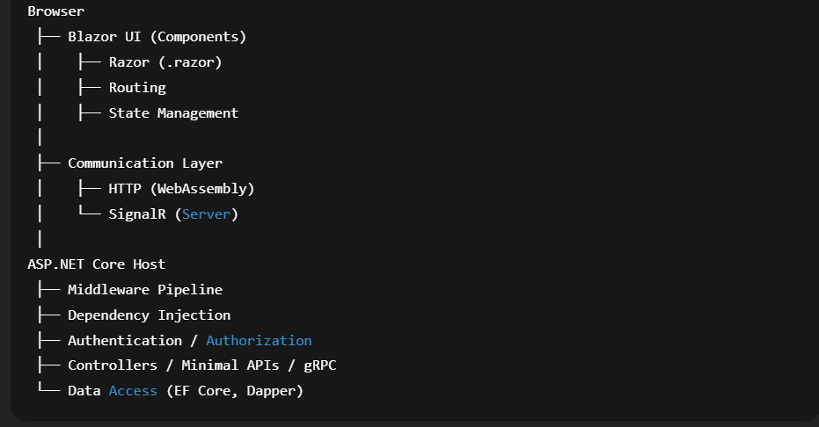
Blazor is not a replacement for ASP.NET Core—it is a UI layer that plugs into it.

3. Core Architectural Building Blocks
3.1 Razor Components
- .razor files combine:
  - HTML (markup)
  - C# (logic)
- Components are:
  - Reusable
  - Stateful
  - Event-driven

3.2 Rendering Engine
Blazor uses a diff-based rendering model:
- UI is represented as a render tree
- On state change:
  - Blazor computes the diff
  - Only minimal DOM updates are applied
This is similar in concept to React’s virtual DOM but implemented in .NET.

3.3 Dependency Injection (DI)
Blazor fully relies on ASP.NET Core’s built-in DI container.
builder.Services.AddScoped<ProductService>();
Scopes depend on hosting model:
- Server: per user connection (circuit)
- WebAssembly: per browser session

4. Blazor Hosting Models in ASP.NET Core
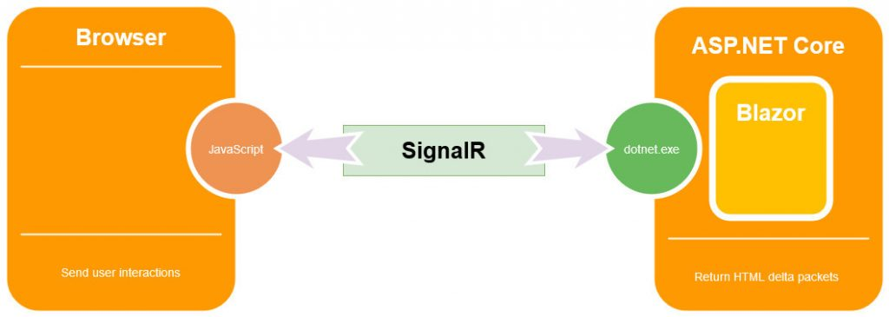
4.1 Blazor Server Architecture
Execution Location
- UI logic runs on the server
- Browser holds a SignalR connection
Flow
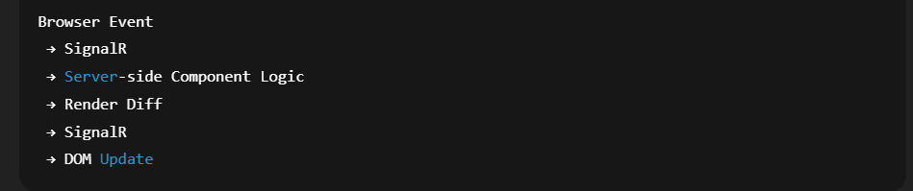

4.2 Blazor WebAssembly Architecture
Execution Location
- Entire app runs in the browser
- .NET runtime executes via WebAssembly
Flow
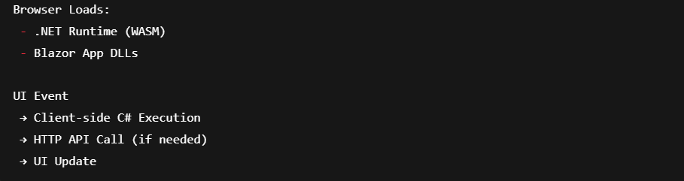

5. ASP.NET Core Middleware Pipeline Integration
Blazor apps are hosted inside the ASP.NET Core request pipeline.


6. Communication Patterns
Blazor Server
- Uses SignalR
- Persistent, stateful connection
- Real-time UI updates
Blazor WebAssembly
- Uses HttpClient
- Stateless REST / gRPC-Web calls
- Same architecture as modern SPAs

7. Security Architecture
- Authentication handled by ASP.NET Core:
  - Cookies
  - JWT
  - OAuth / OpenID Connect
- Authorization:
  - [Authorize]
  - Policy-based
  - Role-based
- Blazor enforces security both at route and component level

8. Deployment Architecture
Blazor Server
- Deployed as an ASP.NET Core app
- Runs on:
  - IIS
  - Azure App Service
  - Containers
Blazor WebAssembly
- Static files (CDN-friendly)
- Backend APIs hosted separately or together
- Ideal for cloud-native architectures

9. Architectural Summary
Layer | Responsibility
Browser | UI rendering & events
Blazor | Component model & SPA behavior
ASP.NET Core | Hosting, DI, middleware
.NET Runtime | Execution & memory management
Backend APIs | Business logic & data

